BIRTH OF THE ELECTRIC SUPER-HIGHWAY
Reference Booklet: 9 October 2022
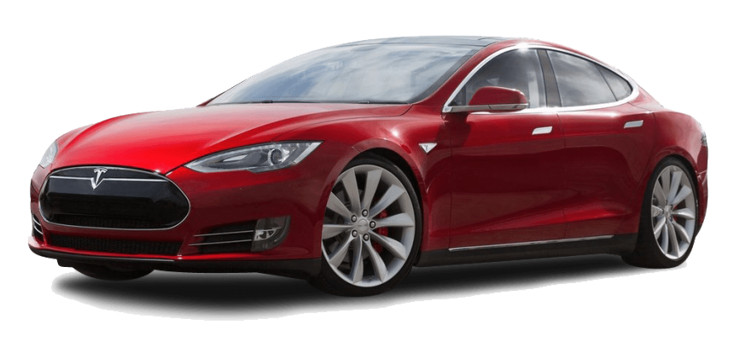
In a few years, electric cars and compact vans will drive autonomously on the high speed tracks of the TEV-System. They will draw power from the tracks without stopping to charge their batteries. Clean power will come from nuclear, wind and solar. So the TEV-System will make a major contribution to reduce global warming. No radical advances are necessary.
. 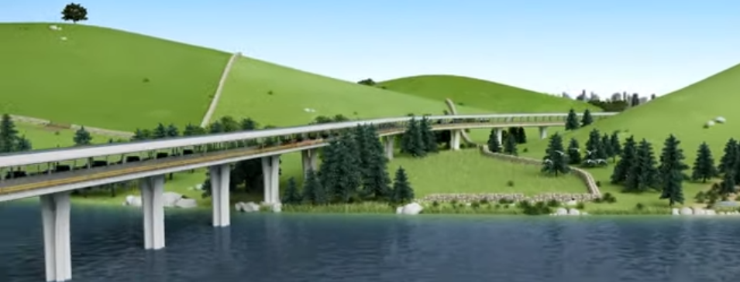

Equally impressive commercially, millions of parcels will be delivered around the world by driverless electric vans. These vans will cruise on TEV-Tracks for hundreds or thousands of miles without stopping. Revenue from the vans will fund track construction.

Contents
1 | Introduction | 3
2 | Some city and suburb vehicles | 7
3 | Vehicle designs | 11
4 | Computer software | 13
5 | Passenger capacity comparisons | 14
6 | Energy consumption of TEV vehicles | 19
7 | Track design | 21
8 | Power for the track | 27
9 | TEV can even restore and revitalize cities | 29

1. The Electric Super-highway starts here!
This booklet proposes a radical, worldwide revolution of our road system to carry people and light freight. It is called a Tracked Electric Vehicle or TEV. TEV uses production electric vehicles such as cars, taxis, vans and minibuses but in a faster, safer and more efficient way than is possible on present roads and human drivers.
One third of all carbon dioxide on Earth is now produced by road vehicles. A major aim of TEV is to help reduce these emissions, world-wide.
TEV stands for Tracked Electric Vehicle. The name describes a restricted-access, electrically powered, extremely safe highway for high-speed electric cars and small vans.
There will be at least two kinds of TEV tracks. One is a high speed version for speeds of 120mph (200km/h) or more. Only streamlined cars and light vans will be allowed on these tracks. Comparing door to door travel over long distances, TEV cars will compete with High Speed Trains for speed and comfort but with greater convenience and safety.
TEV will also have Local Tracks with slower speed limits of about 60mph (100km/h). Many different types of vehicles will be allowed on these slower tracks. Cities will welcome them because they will revitalize city life dramatically. See Chapter 9.
Large freight-carrying trucks will NOT be allowed on any TEV tracks and must use Interstate Highways and other conventional roads. However, given time, those trucks can be electrified with overhead power cables. Development is proceeding on that option. Big trucks will be restricted to drive in automated convoys on Interstate Highways with defined gaps between trucks so they never obstruct the exit of other traffic.
All TEV cars and vans will run on conventional rubber tires and will be much quieter than the shrieking steel wheels of High Speed Trains (HSTs).
TEV cars and other small vehicles will be “dual-mode” which means that they can be driven on normal roads and on TEV tracks.
We envision that the TEV system will become an efficient, carbon-free, international, electric-highway network with all countries using the same standards.
TEV’s high speed electric cars, with their convenience, long-range and endless choice of exits, will challenge high-speed passenger trains (HSTs) and intercity expresses.
Note that TEV cars can go up hills easily on their rubber tires while trains are limited by slippery rails and need very expensive, level tracks in mountainous regions.

Before we move on, an important word about batteries:
A frenzy of advanced battery development for electric vehicles is going on in the world and billions of dollars are being spent. This effort is based on an incorrect assumption that present-day EVs cannot go on long journeys without stopping many times for charging.
In contrast, TEV cars and vans will never have to stop to charge their batteries because they can pick up power from the track and run continuously, day or night. The size of the car’s battery becomes much less important.
But doesn’t that eliminate the need for high capacity batteries? Of course it does! By getting power from the track, TEV vehicles inherit an infinite range. Consider the time saved on a long journey by avoiding superchargers and on the efficiency of having a smaller, lighter battery.
Engineers will agree that the energy efficiency of continuous power will be much higher than charging and discharging the vehicle’s battery. No wasted time either.
So sorry battery development guys; we didn’t mean to upstage your nice batteries!
In summary, a TEV system can use three options to charge electric vehicles on a TEV track on a long journey.
Option 1 is to use conventional batteries like the ones that EVs are equipped with initially. However, the driving range at high speed will be limited by the battery so the car will have to stop to recharge its battery at a Supercharger. That creates conflicts between high cruise speeds, battery weight and battery cost. The more the energy stored, the heavier the battery. Improved batteries will improve the performance but the car will still be range-limited.
Option 2 is a compromise. It provides TEV tracks with intermittent sections of power rails under the cars. These can recharge the EVs’ batteries intermittently as the cars are moving. We call these “On-the-fly Superchargers” which can also deliver an endless driving range if so programmed. These supercharger sections will have a similar efficiency as stationary superchargers but at least the cars will not have to stop to recharge their batteries.
Option 3 is the best choice. TEV will provide continuous power rails under the cars which will power the vehicles automatically. Moreover, they will reduce the cost of energy because the cars are more efficient when running on the power rails than when converting back and forth to battery power. This option also avoids “cycling” the car’s battery on long journeys which will reduce the battery life. The battery can also be smaller, lighter and cheaper. So Option 3 wins hands down.
Lastly, there are strange rumors in the financial investment community that some battery developers are planning to use huge batteries in their cars to achieve longer run times. There is no sense in such an inefficient concept.

Road capacity
We have mentioned that TEV will provide safe travel at high speeds. Less obviously, it can also provide a huge traffic capacity. Roughly, one TEV lane will carry the equivalent of many lanes of road traffic. (More details later). To achieve these results it is essential to have Exits and Entrances that are almost completely separated from the present highway system. Note also that the highway speed limits of most countries are much lower than TEV’s 120mph (200 km/h) continuous cruise speed.
At this point it will be obvious that TEV is not just another well-meaning public-transport system. In fact, TEV’s speed and capacity is so high that it may convince people to move out of the cities to enjoy country living again. (See Chapter 9). Neither is TEV a science-fiction idea based on technology that doesn’t exist – like Hyperloops for instance. On the contrary, it is based on real cars and real roads and is so practical that it cannot fail technically. It is also very compatible with city, suburban or country living. It will handle public and private transport equally well, and will always please its customers so it is likely to be very popular. See Chapter 9.
Compared with the world’s jumble of roads and railways, non-polluting TEV tracks will be faster, safer, more flexible, more comfortable, more energy-efficient, better for the environment and much cheaper to build and maintain than either present highways or railways. Further, it will not need a permanent workforce like old fashioned railways. In addition, it is likely that TEV could free up many old train tracks and stations for use in the TEV system. (See later).
The TEV system will require some initial government support, of course, but not the endless subsidies that high speed trains require. On the contrary, TEV will be a good long-term investment because it will have a vastly higher passenger-carrying capacity per lane of highway than any other system. (See Chapter 5). Also, for longer journeys, TEV may be faster door to door than any other road based transport system, including cars on autobahns. It will also be much safer than autobahns, especially in bad weather conditions.
Better still, TEV will be sustainable, using zero-carbon energy, all over the world, for the next several centuries. That is its main purpose. But even that is just a beginning because TEV will reduce problems like traffic jams, highway fatalities, road noise, diesel fumes, parking problems, dangerous drivers, speeding tickets, road-rage and stress. That’s not a bad record. (See Chapter 9).
At one stroke, TEV will convert the modern car, the universally preferred mode of transport, from being an evil monster that is destroying our planet into a lovable, disciplined and self-funding people-transport system. The basic technology for TEV already exists so it doesn’t need any “breakthroughs”: no magic batteries, no weird propulsion systems; no major technical risks at all. All it needs is competent engineering.

Some history: Automated Highway System
- TEV is descended from a 1980’s concept called “automated highways”, a scheme in the USA that was ahead of its time but which failed due to the inadequate technology of the time. Present technology is much more advanced and self-drive cars are already using public roads, including autobahns.
- The TEV system will be much quicker and much safer that an autobahn because it separates its precious payload of people from all else. Cars on a TEV track can also run safely in close convoys so that they can brake and accelerate together. The reaction times between cars in convoys will be close to zero. TEV cars also have information about road conditions ahead so that all vehicles can react intelligently. The tracks are designed to be intrinsically safe. On a track covered with a roof, an individual could drive safely, at maximum speed, in almost any weather, even if fast asleep. In emergencies, TEV would automatically divert a car to the nearest exit and to a source of help.
The capital cost of TEV tracks will be substantial, of course, but due to their enormous passenger-carrying capacity (see later), the cost per passenger-mile will be quite small. For example, a two lane TEV track will cost much less to build than a typical Interstate Highway and yet have many times more carrying capacity plus a higher cruising speed plus better safety features and plus higher energy efficiency. It will also be powered by clean electricity, not carbon compounds. That’s what we call TEV magic!
Just for fun, compare the building costs of TEV and the High-Speed Trains (HSTs).
At this writing, a High Speed Train project in California is underway and expected to cost over 80 billion dollars. This amounts to 154 million dollars per mile! We estimate that we could build 50 to 100 TEV tracks for this price, with no risk of bankruptcy.
A practical and financial benefit of a TEV Track is that it can accommodate gasoline powered cars so long as they can drive autonomously. This will help shorten the payback time for the TEV tracks. Within a decade or two, however, we trust that almost all vehicles, worldwide, will be electrics.
Common sense says there is no point in stopping CO2 pollution in rich countries if poor countries are still burning fuel for transportation. These people desperately need TEV so they can build sustainable growth without harming their own environment. Note also, that unlike trains, TEV vehicles can easily climb up hills into isolated mountain valleys which usually have poor access to the big cities. TEV will solve that problem and create jobs for people in their own homelands.
So welcome to our vision of the future! We hope you agree that this efficient, pleasant, and environmentally sensible TEV system could be your gift to your grandchildren.
Will Jones, Engineer, Freeport, Bahamas

2. Some city and suburban vehicles used by TEV
A basic feature of TEV is that it uses cars and vans with rubber tires on roads. It also uses slightly modified versions of familiar vehicles such as cars, mini-vans, mini-buses, and other normal vehicles as the primary transport modules for people and goods. This has three advantages:
- First, there will be little initial effort for people to change from an old-style public transport to a new-style public transport. Later it will be easy for the public to convert to the new system because it will be safer, healthier and faster than buses and trains. Think of it as a personal transport system that greatly improves the road system.
- Second, the enormous expenditure required to develop special vehicles will be avoided because cars and vans will readily be produced by existing car companies.
- Third, TEV Track uses a restricted track system on which only EVs and clean, engine-powered vehicles can drive. (The latter will gradually be eliminated). TEV Tracks are optimized guide-ways, where individual vehicles can be driven at high speed under automatic control. TEV They are electric highways that service both cities and suburbs equally well.
Yet another difference is that TEV vehicles will be divided into two types called Single-mode and Dual-mode.
Single mode vehicles, like shuttle buses, will be restricted to drive on the Local (slow) TEV tracks but not on conventional roads. During operation they will usually be driverless.
Dual-mode vehicles, on the other hand, will drive on the tracks under automatic control, but can also be driven on normal roads by humans or by computer. That is not a big leap from existing EVs so current EVs could be adapted quickly.
Of course, the 120mph high speed TEV track is probably the star of the TEV system for people in a hurry, but more humble vehicles will also provide revolutionary changes on the slower tracks. We will begin by describing these vehicles.
Dual-mode vehicles
“Dual mode” vehicles can drive on normal roads and also on the high speed TEV Tracks. The Tracks, not the cars, make TEV very different from conventional transport systems that use trains, buses, cars or trucks. The icons below represent various kinds of TEV vehicles. One dot represents a human driver and the other represents a human passenger.

The TEV car: a revolutionary, privately owned, dual-mode personal transport vehicle for the masses
This privately owned, dual-mode car can be driven by humans or by computers on public roads. It can also use Local Tracks - and Express Tracks, if qualified, using Entrances and Exits.
Dual-mode vehicles may need human drivers when driven on conventional roads but the laws on automatic driving are changing quickly and many cars are already driving without human help. An obvious benefit is that a driverless TEV car could be sent, say, to an airport to pick up its owner, or across a country to deliver an urgent parcel.
Note: This is a somewhat idealized scenario because many vehicles will still be engine driven for a decade or two. Is it possible for those vehicles to run on TEV tracks? The answer is yes, if it does not drive too far and run out of gas! If properly modified, there is no reason to stop them using a well ventilated TEV system, especially during the startup years. They will pay tolls and help build the system.

A dual-mode taxi

This vehicle is a TEV-compatible taxicab with a human driver. It can take a passenger from door to door, like any normal cab. But it can also use the TEV track, so its operating range is enormously extended which improves its value to customers and increases the revenue to the taxi driver. It could also become an autonomous vehicle, with no driver, using roads and tracks,
There can also be some “track-bound” vehicles in the TEV system.
Single-mode, rubber tired vehicles in the TEV system are just as revolutionary as the dual-mode types. They will use the same TEV tracks but, in normal operation, they are driverless and do not leave the track network to exit on public roads. Instead, they stop to pick up and deliver passengers or parcels at prearranged places called Stops which may be public or private. These Stops are analogous to conventional bus stops and are simple, low cost structures. Single-mode vehicles are like horizontal elevators; you get in, the door closes, you are taken to your destination, you get out. Of course, these vehicles never stop on the track as trains do: they always exit the track to let others pass.

A dual mode Robo-van: a revolutionary, driverless parcel-delivery vehicle that can cross a continent

This is the TEV vehicle that will revolutionize parcel delivery. It will probably be the most profitable vehicle in the TEV fleet and pay for most of the track construction. Owned or rented by firms like Amazon, UPS, Post Office and other logistic companies, these robotic vehicles will deliver parcels and light freight, often overnight when energy costs are lower. They could travel many hundreds of miles with virtually no labor cost or double-handling.
For example, parcels could go by TEV directly from a supplier in Europe to a company in Asia or vice versa. Deliveries will be timelier, costs lower and breakages much reduced. Just-in-time deliveries for manufacturers will make all factories more efficient. To repeat: it is probable that the revenues from TEV package delivery alone will pay for the construction of the entire TEV network. How’s that for a good ROI?
These driverless TEV vehicles will be adapted to use normal roads and could also drive on factory floors by following electronic guides to deliver their payload to a specific assembly line. The post offices of the world will also use these vans to simplifyparcel delivery services.
A dual-mode parcel van
This dual-mode delivery van will be used by package-handling companies to make deliveries of high value cargoes. For example, parcels are loaded in secure distribution centers. The locked vans drive themselves to a local TEV Entrance and on to the TEV track.
For high-value parcel, one method would be to park under an opening in the roof of a building and have a robot lift the parcels into a secure space above. From there, the parcels can be made secure inside. This option could halve parcel delivery times and reduce theft completely. The vans may not even need drivers.

Robo-cab: a single-mode, driverless taxi
Robo-cab is another practical vehicle that TEV makes possible for city or suburban use. It is a driverless taxi cab summoned from any TEV Stop. You walk to a TEV Stop and enter your destination number on the phone. When your cab arrives, another swipe opens the cab door.
Video cameras will record all vehicle entries and exits for security reasons. Robo-cabs can therefore be used by children or handicapped people and can go across town, or even across the country if required, day or night. The price of using these cabs will be very low compared with driven taxis and this will make them immensely popular. Some people may get rid of their cars!
Like many other TEV vehicles, minibuses could be adapted to public service. They could be used in convoys for commuter service, like a train, but they are better employed to go directly to a few specific stops in the city. Remember, TEV vehicles never stop on the tracks, so express mini-buses can bypass stopped mini-buses making for much quicker journeys. These are simple rules but these vehicles will quickly replace crowded commuter trains which are appallingly wasteful of the rights-of-way they monopolize as demonstrated later.
We do not want to mention epidemics like the Covid-19 or other dangerous viruses, but they are now a harsh reality in our world. To replace trains, that carry strangers in close quarters, with cars that carry only people known to each other, is obviously a sensible tactic for future virus control. These small vehicles will soon have a clientele of tens of millions of people who are ready to step up to the safe and efficient style of the new public transport system.
Could combustion-engine powered cars be allowed on the TEV system?
Surprisingly, yes. It is quite practical to run engine powered cars on the TEV track – so long as they have the same controls as the EVs and the track ventilation is adequate. It doesn’t make much sense for the long term, of course, because TEV aims to eliminate all vehicle smog. But in the short term, like the startup period of TEV, it would be a good way to help pay for track construction.
Therefore, in the early years of TEV, we may as well allow these vehicles to use the tracks and pay tolls. Everyone would gain confidence in the TEV system quicker that way. It will also reduce the expenditure for the tracks, especially the electrical power delivery system, much lower.
Better still, it would also give people and governments time to get confidence in the TEV system before committing to build a full-scale system.
____________________________________________

3. Vehicle designs
The typical private TEV car will be a compact EV with room for four to six people, plus luggage, as seen on the streets everywhere in the world. Many will be lighter and more streamlined in appearance and use much less energy that present cars. Using production electric cars will virtually eliminate the TEV system’s development time. In just 20 or 30 years, most TEV vehicles in the world could be powered by electric motors on a TEV track.

Local, slow-speed TEV tracks can accommodate roomy, boxy, vehicles that will be much loved by families while Express track cars, in contrast, must be very streamlined. This is not a problem: because we can easily make roomy streamlined cars by having three rows of seats.

A TESLA Model-S, on an autobahn on a dry day, can run for at least 100 miles at 100 miles an hour. That is an amazing performance for an electric car. But it creates two problems. Firstly, most countries will not allow 100mph speeds on their public roads, especially in bad weather. Worse still, the driver will now have to stop to recharge the car battery at a supercharger which will waste time. Presently, even the best EVs can’t drive at high speeds for hundreds of miles without stopping for charging.

That is not an issue on a TEV track. As you drive, you pick up electricity from the track, just like a subway train. By the way, this is much more efficient than any battery. You could drive for a hundred miles or a thousand miles; your battery size doesn’t matter. In fact, theoretically, the lighter the battery the better. You can even run your air conditioner. Being able to drive endlessly at high speed in a battery electric car is what we call TEV magic!

Another virtue of TEV vehicles is that they are equipped with rubber tires which are used on both normal roads and TEV-tracks. More detail on this subject later. In addition, each car has a computer-controlled system for the accelerator and brakes that overrides the driver’s controls. This equipment has already been developed by the automotive industry and is already in production.
The use of conventional cars gives TEV a huge advantage over all transportation proposals that require specially-designed vehicles. The modern car is an extraordinarily well-developed appliance, having had billions of dollars spent on its chassis, suspension, power-steering, air-conditioning, anti-lock brakes, traction-control, electric windows, remote door locks, air-bags, sea-belts and other systems. So, it makes perfect sense to develop a track system based on the sophisticated, modern electric car.
Other options
The ideal TEV car, from an environmental viewpoint, is a pure EV, having a battery, an electric drive-train and the special controls that permit it to drive in track mode. It will burn no fuel and produce no carbon dioxide. It is likely that most of the TEV cars in the near future will be of this type. A nice feature for battery-limited EVs is that efficient, utility-powered air-conditioning is available on the TEV track without draining the car battery! Small things matter.
Restricted vehicle access to TEV tracks
One constraint on the TEV vehicles is that they must be “track compatible.” Vehicles like 18-wheeler trucks or large buses are unacceptable because of the enormous cost of building large tunnels and other infrastructure components. Normal size cars are the best and safest approach and standards will quickly be defined in the Design Review stage of the TEV project.
Banned from Express Tracks, but not from Local Tracks, include trucks, pickups, vehicles with protrusions such as roof racks, vehicles with noisy tires and so on. Only vehicles that have an electronic pass can even enter the Express Track. Others will be denied access and diverted back to the road system.
Local Tracks, with their slower speeds, will be allowed to accommodate pickups, vans and other slower vehicles. Doing 60 miles an hour with no stops will feel incredibly fast in a crowded city because your journey will be much faster than usual due to the absence of stops.
Public service vehicles
The design of public service vehicles will follow the same principles as the car designs. However, since most Mini-buses and Robo-cabs will be single-mode vehicles which will get off the track when they need to stop. They will be electrically powered virtually all the time. A small battery will provide emergency services. In normal operations they will use no petroleum-based fuels at all which is nice for the city as well as the planet.
Rubber tires versus other drive systems
All dual-mode vehicle concepts, TEV or otherwise, must use rubber tires when they travel on normal roads. However, some inventors have been tempted to use a separate support and propulsion system for high-speed travel on the track such as steel-wheels-on-steel-rail or even magnetic levitation (Maglev). TEV uses rubber tires, for both road and track, for both technical and economic reasons. Here is the argument:
Steel wheels have the immediate technical appeal of low rolling resistance – about 6 times lower than rubber tires. But the fault of this virtue is that steel wheels are slippery. This causes problems such as wheel-spin during acceleration, an inability to climb hills and, worst of all, a very poor braking ability. For example, Japanese high speed trains are officially reported to take four kilometers, 2.4 miles, to come to a stop in an emergency, and even more if the track is wet, icy, or covered with leaves. And remember, they don’t have seat belts!
By contrast, a TEV car on a covered dry Track could stop from its cruising speed of 120mph in the length of two football fields (200meters). Poor braking performance is an enormous concern for all high-speed trains because there is literally no solution.
Another serious downside in urban areas is that steel wheels are horribly noisy, emitting a continuous high-frequency whine caused by constant slippage between the steel wheels and steel rails. No one wants to live near a high speed train track. Quiet rubber tires, on the other hand, have superb traction and braking capabilities. Better still, they already exist as part of the modern car and are already equipped with sophisticated control technology like disc brakes, ABS anti-skid systems, torque vectoring systems and more. No radical new developments are required.
Also, modern tire technology has already halved the rolling resistance of older rubber tires by using radial construction, silica based compounds, higher tire pressures, and modifying the design of the treads and sidewalls. These new tires run cooler and are ideally suited to high speed travel of 200km/h (120 miles per hour). What’s more, if tire companies were to design tires specifically for the smooth TEV track surface, we could expect even lower rolling resistances in the future.
The surprising reality, however, is that the higher rolling resistance of rubber tires is irrelevant! At high speed, it is aerodynamic drag, not rolling drag that is the dominant energy consumer. Calculations show that rolling resistance is only about 6% the total drag of a TEV car doing 120mph (200km/h) so that further reduction has diminishing returns. Studies by our Newcastle University engineers calculate that driving cars in close convoys is much more efficient and could gain as much as a 40% reduction in total drag. So, quiet rubber tires are good for speed, carrying capacity, safety and efficiency - and can be used on a TEV track!
Rubber tires are also much quieter than steel wheels. Fortunately, quiet, efficient run-flat rubber tires, essential for the TEV system, are already standard equipment on new cars.
Maglev (magnetic levitation) systems once sounded attractive for high-speed trains, but in that application they have never been commercially successful. Maglev is a very complicated approach if compared with a simple people-mover system like TEV. The company who developed the system has now scrapped the project after spending millions! In any case it was a public transport system, like a fast train. We would prefer to replace it with TEV cars.
The rubber tire, therefore, is a surprising but worthy winner. It is a thoroughly practical solution: reasonably efficient, flexible, simple, inexpensive, reliable, safe, quiet, and immediately available without development programs. For the technically inclined, these are some comparative coefficients of rolling resistances – the drag force is expressed simply as a percentage of the vehicle weight. (My apologies to purists).
Conventional rubber tires 10.0
New low-resistance tires 5.0
Future TEV tires (estimated) 4.0
Steel wheels on steel rail: 1.5

_____________________________________________

4. Computer software
Once a car is accepted by the system for travel on a TEV track, the computers, in-car and central, take over the driving and control everything from the initial safety check on the cars, the acceleration up to cruising speed, the grouping of cars into convoys, the exit of each car at its programmed destination, and even the electronic billing of the customer for use of the track.
This sounds like a big development task but, remarkably, most of the required software has already been created by the car companies. Their original aim in the 1980s was to develop “automated highways” where cars were supposed to drive on autopilot on normal highways shared with other vehicles. That concept was impractical in its time. Just as well because TEV is a far safer alternative.
It is obvious that autonomous vehicles driving with passengers at high speeds on conventional public highways, relying on four small contact patches of rubber for steering and braking, will that be too dangerous to drive at high speed, especially in icy weather?.
However, if the vehicles are confined to a restricted TEV track, especially one with Armco barriers on each side of the cars, plus a roof, plus a heated track if necessary, the high speed concept becomes practical, attractive and safe. All should agree that one could then routinely drive at 120mph TEV Express track.
The good news is that the modern automatic control software, which has been vastly improved since the 1980’s, can easily be transferred to TEV cars. Actually, it is a far less demanding application on TEV than driving automatically on a 1960’s freeway. Cars driven in 1960 required control in both speed and steering, whereas TEV requires control in only one dimension, speed, which is much simpler.
Note in passing: Germany’s famed autobahns are not as safe as they are often claimed to be. The death rates on UK motorways is said to be half that of the autobahns. By contrast, TEV safety cannot be compromised even by drunk drivers. Perhaps the cars need breath testers!
The TEV central computer is, of course, aware of all traffic conditions on the TEV network, making it able to redirect traffic away from trouble spots, or bringing all cars to a halt in seconds in an emergency. To accommodate the computer controls, each car is modified to have “fly-by-wire” electronic control systems, specifically for steering, accelerator and brakes. Again, most of these systems have already been developed by the car industry.
One useful feature is that a car should be able to push or gently bump the car in front without causing damage. Sometimes it may be difficult to brake in a convoy without the cars touching each other. In other times there may be a battery failure and the cars behind the lame vehicle could simply push it to the next exit.
____________________________________________

5. Passenger capacity comparisons (Huge!)
The carrying capacity of TEV is measured by the number of cars that pass a given point in a given time. The calculations involve the following assumptions:
- Most TEV cars are compact in size having a length of about 14 feet (4 meters) with four seats and room for luggage. The shorter the cars, the higher the passenger carrying capacity of the track. Family cars with three rows of seats would have the highest capacity.
- On the TEV track, the cars will be grouped into convoys with about one meter (3 feet) between cars during the cruise mode. This convoy concept is one of the biggest contributors to high passenger capacity and low aerodynamic rag.
- Expected cruise speed on Express Tracks is 120mph (200km/h). High cruise speed is also a big contributor to capacity. Speeds 20% higher and more will probably be practical in due course.
- The maximum “load factor” may be arbitrarily restricted here to 75%. That is, convoys of 30 cars followed by gaps of, say, 10 car spaces.
- TEV capacity can be enormous
If a single TEV track were loaded to its maximum capacity (100% load factor), with all the cars in one continuous convoy traveling at full 120mph (200km) speed, the number of cars passing a given point would be 39,600 cars per hour. But we will assume here that the practical maximum track loading to be 75%, so our practical maximum is 29,700 cars per hour or 30,000 for short. To show how high this capacity is we must compare it with other transport systems.
Compare with highways
A useful rule in the UK Highway Code for spacing cars on a motorway is to leave two seconds between cars, one for human reaction time and one for deceleration of the car. From this we can compute that the maximum capacity of a single lane of expressway is around 1,688 cars per hour. Note that this is for a dry road. Wet roads will result in about half this capacity. TEV needs no reaction time, but humans do.
If you compare this low number with the TEV number above, you will be surprised. A slim, one-lane TEV track has the astonishing capacity of 17 lanes of highway. Probably no-one has ever contemplated such a high capacity on one lane of a road.
Such an enormous capacity might only be useful in an evacuation during a hurricane. If a TEV track were loaded bumper to bumper with cars, the electrical load on the track would be about 5,000kW per mile of cars (3,000kW per km). A curious fact is that TEV could handle this enormous load quite easily, even if the local power company could not. Why? Because the TEV cars can use their own batteries!
This enormous potential capacity of TEV gives us a hint of real advantages that are available for building the system, especially using narrow bridges and tunnels. For example, we could convert one lane of the George Washington Bridge into New York into a double-deck TEV track. A commuter could drive her car across the bridge on the upper level, disembark and send the car back home to New Jersey, all without creating a parking problem. Clearly, the sheer capacity of TEV offers enormous new opportunities for public transport systems in the future.
TEV construction cost
If the road construction cost per unit capacity is compared, TEV’s superiority widens further. A modern interstate highway with 3 lanes each way could easily cost $10 million per mile to build in open countryside. By contrast, a simple TEV track, with one lane each way, will likely carry over ten times the traffic, cost one tenth of the money to build per unit capacity, and have one tenth of the environmental impact during construction and operation.

But to be fair, the great virtue of the traditional road system is its flexibility. It can carry everything from bicycles to monster trucks. But that is also what makes it so hard to manage. Look to the overloaded roads in India for example. The virtue of TEV is exactly the opposite. By focusing on carrying people and light freight it avoids most of the compromises of “flexible” road travel. Thus, its capacity is dramatically increased. A separate conventional road system with electrically powered driverless trucks, will revolutionize that transportation sector also.
Observations confirm calculations
Two major 6-lane highways were compared, the M6 in Manchester, UK, and the Pennsylvania Turnpike, near Philadelphia in the USA. They were observed for their traffic patterns during peak periods. On both occasions, the measured capacity per lane was lower than the 1688 vehicles per hour estimated above. In fact, it was close to a pathetic 1200 vehicles per hour.
The obvious reason for this was that the two “slow lanes” were occupied by heavy trucks, trying to pass each other, with long spaces in between. The car drivers, not wanting to share the truck lanes, gravitated to the third remaining “fast” lane. That became clogged also with cars driving too close for safety.
TEV gets its superior capacity by having all vehicles maintain the same cruising speed. Trucks should always be in the slow lane, with reasonable gaps in between and only computer-permitted passing.
High speed train capacity comparison
But what about advanced high-speed trains; how do they compare in passenger carrying capacity? Let’s find out.
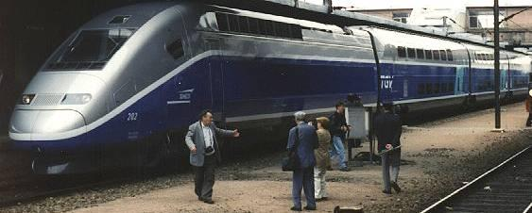

Among the iconic and advanced high-speed trains in service today are the French TGV trains. (Train `a Grande Vitesse). These beautiful masterpieces of engineering cruise up to 290 km/h (180 mph) on a network of dedicated high-speed rail tracks. They can also go more slowly on older, conventional tracks. The TGV is a successful and popular innovation in France, and not only competes with the airlines, but has reportedly paid back its own construction cost in the first 10 years of operation. It is, therefore, a prime yardstick for comparison when future passenger services are discussed.
Note: Just to challenge the false impression that high speed trains are the only option for the future, it should be mentioned that only two of these lines in the world were profitable in the year 2015, the Paris-Lyon line and the Tokyo-Osaka line. Both were built in the early days when money was cheaper. We can assume that all new high-speed train lines will be permanently subsidized. TEV will not fall into that trap because people will be buying their own cars.
The capacity of a single track of a high-speed train, in terms of people carried per hour, depends only on the number of seats per train and the number of trains per hour. Since the train stops and starts in stations along the track, the maximum cruising speed is not a direct factor in the capacity calculation as it is with the TEV system. We will use the TGV double-deck cars with the high capacity 800 passenger version as a yardstick and assume all seats are filled.
The published maximum frequency of TGV train service at peak hours is 16 trains per hour which, when multiplied by 800 passenger seats per train, makes the capacity per track 12,800 passengers per hour – equivalent to 3,200 cars per hour. According to our capacity definition, that is roughly equal in capacity to two lanes of conventional motorway. Oops! That’s tiny.
But that is not the biggest limitation of the high-speed train. There is a fundamental one, which is that train stations must be placed far apart or else the average speed drops precipitously. To illustrate, if a TGV train has to wait 5 minutes at stations that are 50km (30 miles) apart, the average speed of the TGV train can drop to 200km/h (120mph) which is the same as a TEV car that doesn’t stop at all. Stopping on a track is a tremendous waste of speed and passenger capacity. By contrast, TEV cars can exit their track without slowing anyone down.
Another bad practice is trying to use old, slow, railway tracks to carry new HSTs into stations inside cities. In the USA, the Acela train from New York to Washington DC achieves 150mph (240km/h) in some open spaces but averages only 84 mph (134 km/h) for the complete journey. TEV which averages nearly 120mph would be much faster point to point. Worse still: if your mother lived in between train stations she would have to wait for a taxi to get home. TEV would simply take her home.
Could it be that the passenger train is finally out of date? Nostalgia apart, this seems inevitable. TEV can use the space to much better effect (see Chapter 9). The reduced average speed of trains due to stopping in stations can only be partly avoided by having long distances between stations. Fast trains, therefore, are like inter-city expresses or airlines. To be really fast they should only stop, briefly, on the outskirt of cities.
TEV cars don’t stop like trains in stations because TEV has no stations! The tracks have exits but these don’t affect the cars’ average speed on a track. So, our calculations hint that TEV journeys will be faster in many door to door journeys than on high speed trains!
More good news. By using small tunnels or reusing old railway lines, TEV low speed vehicles could go into the heart of old, established cities as easily as they could go into the countryside. Cars are much more flexible than lumbering trains. And remember, two TEV tracks can be stacked in one disused railway tunnel. See Chapter 9. Does that make it a 34 lane track?
How do commuter trains compare?
Most people would assume that the commuter train, crowded with passengers, has the highest passenger capacity of all. But they would be wrong. Even though it is cramped, uncivilized and unhealthy, the commuter train can’t come close to TEV for capacity because the train must stop on the track in each station, which will ruin its capacity. To match the capacity of a single TEV track, a commuter rail line must service one 500 passenger train, every 15 seconds. This would be impossible because the train must stop in each station for longer than that. One London Underground suburban station had a commuter train that rolled by every 10 minutes. In that case, the capacity of the rail track was about 3,000 passengers per hour, the equivalent of 750 cars per hour, or half the capacity of a single lane of highway. This makes the commuter train the worst people mover of all.
Results and conclusions on capacity
For a fair comparison between train, road cars and TEV cars, we must compare passengers carried per hour per lane. With each road car and TEV car having four seats, this is the result:
System | Speed (mph) | Vehicles per hour | Passengers per hour | Equivalent road lanes
Highway, one lane | 70 | 1688 cars | 6,752 | 1
Commuter train  one track | variable | 6 trains | 3,000 | 1/2
High Speed Train  one track | 180 | 16 trains | 12,800 | 2
TEV, Single track | 120 | 29,700 | 118,800 | 17

A big surprise is that the TGV high-speed train only has a capacity equivalent to two lanes of highway traffic. The 16 trains per hour figure corresponds to a rate of one train every 3.75 minutes. That is, if a train stops in any station for more than this it will hold up the following train.
Another waste of resources is the city commuter train. The priceless rights-of-way that trains use to get into a big city could be put to better use by TEV mini-buses ad hire cars which could supply all the peak passenger traffic quickly. Other TEV vehicles, like parcel vans, could use the same TEV tracks during other times of the day.
But the most remarkable conclusion is that the simple, low-cost, TEV track has a much greater capacity than freeways or high-speed trains or commuter trains. Its combination of speed and capacity puts it in a class of its own.
But let’s arbitrarily reduce the claimed theoretical capacity of TEV from 17 lanes of highway down to 10 lanes – just to make a round number. Few would argue that TEV track lane can easily be made to carry 10 road lanes of traffic. That is enough advantage to justify construction of the TEV system. _____________________________________________

6. Energy consumption of TEV vehicles
Suppose we developed a magic battery that gave electric cars the same range as conventional gasoline-powered cars on normal roads. Would that option be as good as TEV? Absolutely not. Why? Because the TEV Track does not have the traffic jams, stop lights, intersections, accidents, road-repairs, bad drivers, parking problems, bad weather and all the other causes of stoppage.
TEV’s energy efficiency is high because energy is not wasted in stopping and starting on the track. It is improved further by the combination of smooth TEV-track surfaces, low-resistance but high friction tires, streamlined car bodies, banked turns, direct supply of electrical power to the motors, and aerodynamic drag-reducing techniques made possible by using convoys.
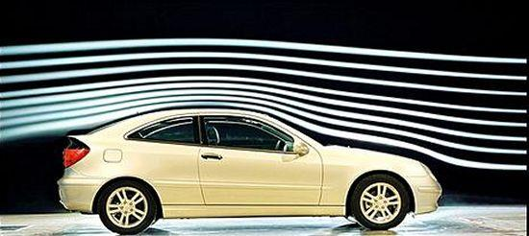
Modern cars can have very low drag coefficients but still look normal
Because of these “natural” advantages, we would expect TEV vehicles to consume less energy per passenger-mile than conventional cars on a normal road system. However, we would not expect TEV cars to be competitive with streamlined, high-speed trains running on steel wheels, would we? Let’s find out.
A Japanese “Bullet Train” traveling at 270km/h is reported to consume only 55 watt-hours of energy per kilometer per passenger – counting half the seats as occupied by passengers. The French TGV train is said to consume the same amount of energy per kilometer, but at 300km/h, and with all the seats occupied. In both cases, the consumption figures equate to a continuous power draw of 10kW per counted seat which is a useful comparative measure to have. So let’s compare TEV with super-trains on that measure.
To match the figure of 10 kW per seat, a four-seat TEV car would have to draw just 40 kW of continuous power at 200km/h (120 mph). We can estimate the approximate power consumption of the TEV vehicle, even if some of the drag forces are difficult to compute, especially (1) the possible increase in aerodynamic drag of the cars within the partial enclosure of the track and (2) the very substantial reduced drag from the “drafting” effect of convoys. Therefore, we will ignore both these factors, expecting them, at least partially, to cancel out.
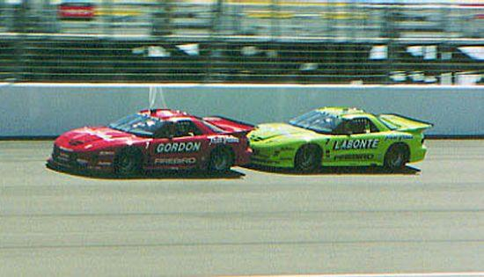
Two drafting NASCAR vehicles doing 200mph (321km/h). Note that they are almost touching.
We will assume that the TEV car is a compact, weighing 2000 pounds (900kg) and having a normal frontal area and a very streamlined shape with a low drag coefficient of 0.15. This is achievable in practice (e.g.: GM Precept) and, therefore, should be made the target.

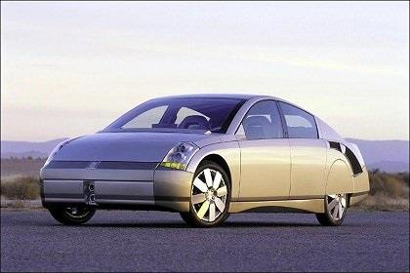
The GM Precept experimental car built in 1999 had an aerodynamic coefficient of 1.5 to 1.7. It looks quite practical.
Back to the calculation (in American units): the resulting aerodynamic drag force at 120 mph would be 116 pounds of force. The rolling drag of the special low resistance tires, is estimated to be only 8 pounds of force. Therefore, we get a total drag force of 124 pounds. This drag force at 120 mph equates to 40 brake horse power or about 30 kW. Allowing for some energy conversion losses, the actual power consumed by the vehicle would be about 40 kW, an amount identical to the TGV train doing 180mph and twice that of the Bullet Train doing 160mph.
Thus, the total amount of electricity used by the TEV car is quite low. For example, a journey of 120 miles could be done in one hour with an energy consumption of just 40 kWh which, even at 10 cents per kWh would only cost $4.00 in “fuel” costs. (Note: The actual production cost of electricity can be as low as 2 cents per kWh so it is an exaggerated cost).
By contrast, a fuel-burning car on a normal road, consuming gasoline at a frugal 30 miles per gallon would use 4 gallons on the trip going much slower than 120mph. Using American gasoline prices at $3.00 per gallon at the time this report was written, fuel would cost $12.00 - or 3 times more than our clean EV. Using expensive European petrol prices of $6.00 per gallon, it would cost $24.00 – 6 times more. Of course, petroleum prices are largely made up of taxes, as are electricity prices. Still, it shows that the cost of TEV travel is lower than present systems and not inevitably higher, despite their higher speeds.
Note also that EVs will be more energy efficient driving on the TEV tracks than driving on the roads using their battery power. The reason is that the electricity goes directly from the electrified track to the drive motors. Energy is not wasted going through a charger and battery.

Incidentally, the faster the charge rate the less efficient it is, so fast charging is always wasteful.
_____________________________________________

7. Track design
The basic definition of a TEV track is a single-lane each way, electrically-powered, limited-access roadway with no intersections other than ON ramps and OFF ramps.
A single TEV track is quite narrow: just the width of the car plus the space necessary to allow passengers to exit their cars, on both sides, in an emergency. To eliminate the possibility of the cars being thrown off the track by any foreseeable event, including terrorist attacks, there are strong ARMCO type crash barriers on each side of the vehicles plus a third rail to keep the vehicles safely inside in a crash or emergency. The ideal may be a TEV track with two main lanes plus a third lane for emergencies. That makes for a very safe, compact and efficient system.
This contrasts with conventional trains which can derail with disastrous consequences. In 1998, the advanced German ICE train damaged a wheel and crashed into a bridge abutment killing over 100 people and injuring over a hundred more. It was only doing 120mph (200km/h).
In TEV vehicles, occupants are so well protected by safety equipment such as side barriers, air bags, crush zones and disc-brakes, that even in a terrorist attack, very few people would be injured or killed. Trains have none of these safety features. It is not obvious but TEV cars will probably be much safer than in a crash.
A fundamental purpose of the TEV track is to make travel intrinsically safe. Therefore, there are no objects on the track that can cause high frontal impact or nasty accidents:
- no trees, telephone poles, walls, ditches
- no head-on crashes or two-way traffic (exception as discussed later)
- no intersections, crossroads, railway crossings, traffic lights
- no farm tractors, motorcycles, bicycles, school buses
- no sheep, cattle, pets, wild animals, pedestrians
- no heavy trucks, trailers, flatbed trucks, open pickups
- no drunk drivers, speeding drivers or bad drivers of any kind
All this is possible because TEV is a highly-segregated transport system, concentrating on carrying the most precious cargo of all, people, plus some light freight to help pay for construction and maintenance.
Stacking of tracks
A pair of TEV tracks can be placed side by side as in a two-lane road. However, they can also be stacked one on top of the each other in double-deck fashion. The double-deck arrangement has benefits of structural strength, useful when making long spans, and is perhaps nicer for passengers who might enjoy the extra view. Probably, the arrangements will vary with local opinion. A double deck arrangement would also make very economical use of existing tunnels and bridges. On the other hand, the tracks themselves must look nice from the outsides
As mentioned earlier, a double deck track arrangement could be made with conventional light freight vehicles running below at a slower speed, and passenger cars running at high speed above. This might turn out to be an ideal infrastructure for the future. These concepts can be resolved in design review meetings. TEV tracks can also be laid down in several unusual ways, as follows:
Using old railway tracks, on the ground or elevated
The following is one of the lowest-cost options. In most developed countries, there is a network of railway tracks that not only cross the countryside but also drive right in to the centers of major cities. Often these tracks are underutilized. To waste such an asset as a right-of-way into the very heart of London, for example, for such a crude mode of transport is a terrible waste of resources.
Cannibalizing underused railway tracks outside cities and converting them to TEV tracks is another important resource. Don’t mourn the loss of archaic systems; we will be better off with TEV, especially when you must travel at some lonely hour on a dark night. There is almost nothing a train can do that TEV can’t do better, safer, cheaper and often faster.
Replace the “fast lane” of a freeway
Here is yet another way of cannibalizing underused assets: construct TEV Superhighways in place of the fast lanes” of a 3-lane each way highway. Assume one track in each direction with a strong crash barrier to protect the TEV vehicles from the other road traffic. This option has a big advantage because there are obviously many existing rights-of-way available. Due to its huge capacity, the TEV tracks will not subtract from the capacity of the highway, they will add enormously to it at low cost. Bridges, tunnels, and so on suddenly become cheap. With one TEV-track replacing one lane, the yield is the equivalent of 10 extra highway lanes if full speed can be maintained.
On elevated tracks (TEV on columns)
This is the preferred option for new tracks when crossing farms or parkland or passing through low-density suburbs. It provides for minimum environmental impact for both local people and for animals. It also allows the double use of land, like rice growing, which would be valuable in crowded countries like India. Preferably, the track should be supported on columns which are all that is needed for the relatively lightweight structure. Proper landscaping will reduce the visual impact to a minimum. Tracks may be single-deck or double deck. Elevated tracks also work when used down the center or sides of a multi-lane highway or along a power-line corridor.
TEV tracks can also be placed in cut-and-cover tunnels to carry people in and out of cities. The same technique can be used for tunnels under public parks or other scenic sites. The tunnels are so small for their carrying capacity that their cost is a tiny fraction of any other tunnel system.
In small-bore tunnels
An exciting opportunity is the creation of dozens of bored tunnels under our cities. London, for example. These would provide an underground network that would eliminate the city’s intractable traffic problems. Imagine the result: absence of traffic jams, road noise, diesel fumes and pollution. But, importantly, it would not be done by restrictions which say that you can’t drive here or park there. It would be a city of opportunities where you can go where you like and have your car park itself when you get there. See Chapter 9.
People who worked in the city could zip from the commercial center to the airport in minutes, not hours, day or night. They could live in the suburbs without having a dreadful commute. They could dress up in the evening and drive into town in their own cars or in economical Robo-cabs in civilized comfort, to visit theatres, museums, restaurants or galleries without bothering any of the people who happen to live in areas in between.
Modern tunnel-boring machines are very efficient machines and have reduced the cost of tunneling significantly. The cost of a tunnel is closely related to the amount of “muck” that is removed, so the larger the tunnel, the higher cost per mile. However, a very small tunnel is costly too because the muck cannot easily be removed. Thus, the least costly tunnels are ones with a diameter of about 6m (20 feet), an ideal size for two lanes of TEV – plus some extra room for pipes, cables, and other utilities that will bring in a lot of extra revenue. Rights of way are extremely valuable assets. A twin tunnel also provides space for a safety escape path.
The cost of boring TEV “micro-tunnels” is much cheaper than digging large road tunnels for highways. So, we could bore lots of these “micro-tunnels” under many cities and bring the TEV system into the heart of metropolitan areas without disturbing the people on the surface, all at a reasonable cost. Furthermore, existing tunnels under rivers and channels such as the Lincoln Tunnels in New York City could have their capacity greatly increased by converting to the TEV format. That would save another pile of money. Road or rail bridges across large spans anywhere would likewise have their capacity transformed at a trivial cost.
Track enclosures
TEV tracks can be made fully open to the sky and that might be a suitable low-cost approach for some long runs in remote areas like the American prairies. However, for most applications, a roof on the track will probably be a worthwhile enhancement both for the travelers and for the local population.
For travelers, a roof is a great benefit in snowy regions because it keeps the tracks clear. Energy-wasteful snow-plowing is unnecessary and the tracks are usable under most weather conditions. Sprinkling salt on roads is corrosive and may be largely avoided on TEV tracks.
In rainy regions, a roof keeps the track dry, enhancing tire friction and eliminating water spray. In sunny climates, a roof shelters the cars from solar radiation and reduces air conditioning loads to conserve energy further. In sunny places like Saudi Arabia, the Track roof could be covered with solar panels that could produce enough electric power to be worthwhile.
For the local people who live near a TEV track, an enclosure could reduce road noise which is mainly tire and wind noise. The use of sound-absorbent materials inside the enclosure would trap most of this. In addition, the sides of the enclosure can be partially or completely enclosed with glass windows or even mirrored glass window to make the noise and also the cars “disappear” in built up areas.
In case you thought that high speed trains were nice, quiet, civilized things, you might like to check on the noise made by an ICE train doing 300km/h on YouTube.
Track construction and repair
TEV track structures have a relatively light construction compared with roadway bridges because they do not have to carry heavy-truck traffic. Ideally, track sections can be mass-produced in factories and brought to the site for installation. That is a quicker and less disruptive method than that used in road building, not to mention the improved precision and quality control. The speed of construction for TEV could be breath-taking, as fast as 1 mile of construction in every 8 hour shift.
Maintenance and repair of the track roadway (called friction surfaces) is also easier to do than with conventional roadway maintenance. The running surfaces of the track may be twin ribbons of steel, coated in tungsten-carbide grit, upon which the tires run. These could be manufactured in clean factories with engineered accuracy.
The friction surfaces would be designed in conjunction with the vehicle tires to minimize both noise and rolling resistance while retaining good grip for acceleration and braking. Preferably, they could be delivered to the site from the factory as long strips and attached to the track structure with bolts or other attachments.
Road surface repairs will be rare because the intrinsically low wear-and-tear is due to the absence of heavy trucks, lack of frost and few emergency braking loads. Also, the development of durable tungsten-carbide wear surfaces will make the road surface very long lasting. And when the road does need repair, it will be accomplished more quickly and efficiently by removing the friction surfaces on reels rather than using normal road repair methods.
Express Tracks and Local Tracks
The TEV concept should have electric power supplied to its long distance, high-speed Express Tracks and also to its shorter, slower Local Tracks. The latter will displace many stationary Superchargers in due course.

_____________________________________________

8. Which power for the track?

Should electrical power be supplied to TEV vehicles by traditional contact rails or (say) by new-fashioned induction? This might be a major decision for TEV so here is some background.
The usual method for charging an EV is to plug it in like an appliance. Mobile phones, on the other hand, are equipped with inductive charging where you put the phone on a charging pad. Recently, electric vehicles have been equipped with induction coils so you can park your EV over a charging pad at your local supermarket and charge your battery while you shop.
Dynamic induction is in its development phase.
Engineers are now working on a system called dynamic induction where EVs could be charged continuously on a modified road. This concept sounds great but we suspect that it will be unreliable. It may require a multitude of induction pads to be located under the vehicle between the wheels, or on one wall beside the track. The safety issues are also a problem. This is a project more suited to an engineering development program in a university and is far too expensive and unreliable for a hard working real-system like TEV.
Catenaries, pantographs, and high speed trains. What is high tech?
We must be aware of biases. Modern high-speed trains, like the French TGV that carries hundreds of passengers, are not old-fashioned products. On the contrary, they use very innovative technology in every phase of their operations. But they don’t use induction power to drive the trains. Instead they use an “old-fashioned” overhead copper wire in direct contact with a pantograph like the systems used on trains and trams for generations.

The continuous power needed for a single TGV train is enormous, over 12 megawatts. Does that make the high speed train technology old-fashioned? Of course not, it’s a highly-refined concept which is also practical and efficient. Most importantly, it works reliably in the real world at high speeds and high power levels, in the heat and in the cold.
The TGV train has one pantograph which draws several megawatts of power from an overhead “wire”. This wire has a diameter of 15mm (3/4 inch) and is kept at a reasonably constant height by suspending it from a second, catenary support-wire above. All the power to the train goes from the lower copper contact wire to a single carbon brush on the train pantograph. The power wire is zigzagged horizontally between support poles to equalize the wear on the carbon brush.
Obviously, this works very well on the reliable TGV. It is excellent, practical engineering: sophisticated and robust, now used all over the world on high speed trains. We must never denigrate existing, proven and efficient technology as “old fashioned”.
Dynamic induction
Dynamic induction is very new engineering topic so we don’t know much about its practicality. However, we do know that dynamic induction technology, for TEV vehicles on the fly, would be vastly more complicated than for a single charging pad under a parked EV in a MacDonald’s parking lot. It would involve inducing a huge amount of power, continuously, for convoys of vehicles driving at 40 kW per vehicle. It will be also be very expensive per mile. It’s cardinal sin, however, is that it will almost certainly be unreliable. TEV must have systems that are as reliable as trains, not cell phones. We will leave it to experimenters to find out for themselves what “real costs” actually mean.
- Linear induction
There is also another type of induction system designed by the brilliant engineer Eric Laithwaite. Again it almost made sense for an old fashioned train, but never for TEV.
Which power delivery system is best for the real world?
We can’t say which system is best but we can say that TEV has an excellent option in a twin aluminum DC power rail system with stainless steel wear surfaces. It is proven, has high reliability, high efficiency, and is low in cost and easily recyclable. One cannot overstate the following importance of these systems in the real world.
The benefits of the aluminum/stainless steel include:
- No moving parts to wear - except replaceable carbon pickups which car owners will replace at their own cost.
- No delicate electronics to fail.
- Aluminum power-conductor rails which are low cost extrusions.
- Aluminum as a metal is almost inexhaustible in the world, at low cost.
- Experts in aluminum conductor rails already exist in the railway industry.
- Aluminum power rails can be extruded anywhere, even in the developing world.
- Damage is easy to fix and unlikely to be substantial. Parts are easy to replace.
- Aluminum is 100% recyclable which is impossible with electronic systems.
- Under no conditions should complex electronics be installed on or under road surfaces.
- Aluminum power rails are flexible in design and compatible with pre-assembled TEV track modules as shown on the TEV website.

Sketch of power supply to the TEV Track.

- 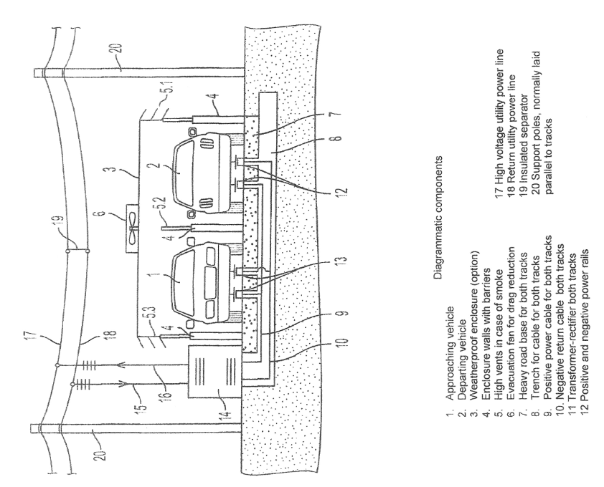

9. TEV’s greatest contribution may be a revitalization of our traffic-choked cities.
It should now become self-evident that most large cities in the world are in decline because they are clogged with vehicles of all kinds. Converting to electric cars is no help if parking spaces are not available. Transport in and out of cities has become a nightmare due to heavy traffic. Taxis, vans, private cars and freight vehicles are so pervasive that they are collectively killing the city.
The tired old solution to use crowded public transport on jammed roads has also failed. Worse still, after the virus pandemic of 2020+, there is an understandable hesitation to use buses at all. Public transport is chronically inefficient and will die soon because the soul has gone out of it. But do not mourn for it, because a better option is here.
Who then will save our cities? Who will remove the blight of road traffic from our streets? Who will nurse the rebirth of the city as a pleasant, safe and healthy place for residents and visitors alike? City managers can’t rescue us because, bless their hearts, their consuming effort is to solve people problems. The city problems, by contrast, are deeply technical and only radical technical approaches by engineers and architects can solve them.
It sounds ridiculous to say that our cities are dying simply because of parking problems! But that is close to the truth. Everyone wants a car nearby but there can never be enough parking spaces nearby. Fear not: the good news is that TEV is the best solver of parking problems - ever. The following is one outline of a TEV solution for dealing with traffic in a large city on a fundamental level.
This plan can be either an elevated track system or a tunnel system to separate the traffic. To keep it simple, we will choose the elevated road option for this example. Here goes:
- Build an elevated ring road around the outskirts of the city. Call it the Outer Ring Road.
- Build an underground Inner Ring Road around the city center.
- Build a number of tunnels joining the Outer Ring Roads to the Inner Ring Roads. Call these Radial Roads. There will be no traffic lights or other conventional controls of any kind on the roads because all the controls will be in the vehicles. Traffic will also move smoothly under automatic control.
- The Radial Roads will resemble spokes on a wheel. Like all TEV systems, these tracks will have no traffic lights, junctions, cross roads, bus stops, pedestrian crossings or any other traffic-delaying systems. They will, however, have several entry and exit points for the vehicles which will eventually all be EVs.
- In any one of these radial tunnels, your electric car could drive you into town at a steady 60 mph with no traffic jams at a mile a minute. This takes only 5 or 6 minutes, not the usual hour or more. Your car might switch to other tunnels along the way. These tunnels will be used to connect to parking garages in low cost parking areas.
- Arriving, say, in the city center parking area your driverless car would park itself in some queue somewhere. You don’t care where. You just get out and go about your business.
- Parking a car in a city will now be a simple and safe maneuver. On command, your car will drive away automatically to a car park somewhere nearby or miles away. You don’t care. So now you have been driven into town and the car has parked itself somewhere safe! How nice! You can get down to business.
- For large cities, with many cars, a more sophisticated system can be installed called a Parking Control Center. (See drawing). An exit from the Inner Ring Road tunnel connects directly to the floor of the Control Center. Your car enters the Center, stops and you exit your car. The car then drives itself out of the Center to a certified and convenient parking lot. You can go about your city business without delay because you don’t have to find a parking space. TEV does that. The car park might even be out of town but TEV’s speed can compensate for that also. To go home after your city visit you recall your car by cellphone or free public phone. The car will pick you up, take the best route to drive you out of the city and drive you home.
- To avoid expensive short term parking, the Control Center will temporarily park the cars inside a convenient location for a fee based on time parked. For longer term parking like an overnight stay, the Control Center will send the driverless car to a less expensive location where it can be parked in safety and recalled when needed. Note that the car may be parked miles away after the owner was dropped off conveniently outside a theater. There is no downside to this arrangement.
- For all-day parking, or longer, the cars can be sent out to even lower-cost parking locations further out of town. The cars can then be recalled when required into any Parking Control Center in town to pick up their owners. It may sound strange but, at TEV’s normal speed, and in the absence of delays from traffic jams and traffic lights, the waiting time to get your car from an out of town car park will only be a few minutes. You could also order the system to make the car arrive at a specific time.
- A variation of this arrangement could be long term parking. For example, if you actually lived down-town you could send your car to a park out of town to keep parking costs low. You would recall your car some minutes before you needed it. So solving the problem of parking in cities is not only possible, it is quite easy with TEV. Gone is the congestion with the ground traffic competing for parking spaces.
This simple parking system will pay for itself by eliminating most of the problems of parking inside a city. In a TEV world, therefore, most cars will never drive on city roads controlled by traffic lights and shared with trucks, buses and other traffic. The cars will travel in TEV tunnels or on elevated TEV tracks inside or outside the city without the problems of traffic lights, cross roads, bicycles, pedestrians and other obstacles. Only TEV can create that option so easily.

Other parking examples.
As shown already, a TEV car doesn’t have to park close to the place where its driver disembarked. It is free to move away from expensive short term parking under automatic control to suitable TEV-Parks outside the city center or anywhere where the fees are cheaper.
The TEV computer never has to look for a parking space because it already knows where they all are. You don’t need to know where your car is parked either because it will simply arrive at your chosen location when you recall it. TEV is your servant, not your tyrant.
Better still, instead of having wasteful train stations, we predict that, one day, cities will have efficient, automated pick-up zones and drop-off zones with plenty of short term parking space for EVs. In time, TEV cars will replace the out of date passenger train itself. High speed inter-city trains will continue to exist but they will sensibly have their stations on the outskirts of cities so they can maintain high average speeds.
In summary: on arrival at a drop-off or pick-up station inside a city, you will exit your car which will park itself somewhere safe while you see to your business. You don’t have to know where the car is. When you recall it, it will arrive and wait for you in the short-term parking zone at the time you requested. If you don’t turn up, your car will go back automatically into short term storage. If your electric car battery is low, it will automatically be charged.
It is clear that the “impossible” problem of city parking is not impossible at all. For TEV, it is not even difficult. In a city, electric cars will never use surface roads, or take part in traffic jams, or pollute the city air, or occupy parking spaces, or make a noise, or need re-fueling. Bad weather will not affect them. They will get in and out of the city quickly, even in rush hour because there are no traffic lights on a TEV track! The overhead or underground TEV Tracks will be largely invisible, yet provide a level of convenience, speed and service to their users that no other mode of city transportation can match.
In our optimistic view of the future we will never see a smelly gasoline tanker truck on a road inside a city. Somehow, that seems to be a gold standard for success.
A final pleasant option is that your driverless car could now take you to the airport without traffic jams and then drive itself back to your home in the countryside as you fly to your destination. The high capacity of the TEV track makes all of this easy. Have a nice flight!
Eliminating old-fashioned train stations.
Once upon a time, a train station was a Very Important Place, located in the center of every city. If you lived in the suburbs you would leave home early in a taxi and get to the station in time to catch the train. In the winter, the station would be miserably cold. Eventually, the train would trundle in and you would get aboard. All that effort just to get a seat next to someone with a nasty cough. Then you would wait until all the passengers were on board. The train would finally trundle out of the city on its way to its destination. Doesn’t this sound appallinly out of date?
Now compare how TEV works. First, you may never have to go to any train station again! Instead, you will start from your nice warm home by entering your destination on your car’s navigation system and letting the car drive you automatically on public roads to the nearest TEV track. Once on the track, you can settle down for a nap. There is absolutely no fear of catching any viruses. The car will wake you up as you approach your TEV exit and then drive you automatically on its battery power and on conventional roads to your destination. Who needs the bother of old fashioned, inefficient passenger train stations now? Get rid of them! Replace them with Parking Control Centers as shown below.
Parking Control Centers.
What is the rate of entry and exit of vehicles from a Parking Control System in a big city? How will you handle Football fans on the day of a big game? Will the traffic cause traffic jams on the surface roads? TEV can solve all those problem.
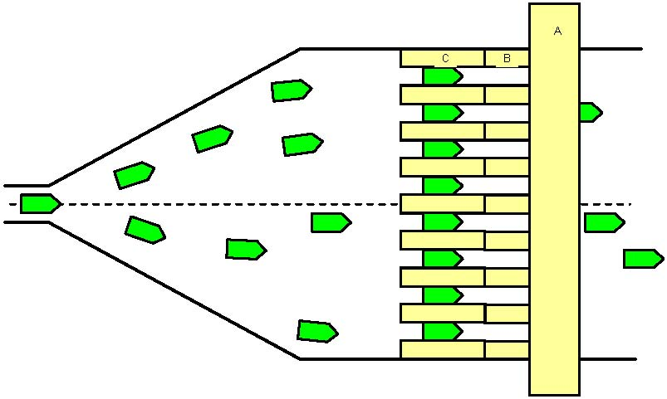
Schematic of an 8-bay TEV Parking Control Center
The sketch above shows a medium-sized Parking Control Center with eight bays. Note that there are no ugly railway tracks, just flat concrete floors for the rubber tired cars. The bays will adjust to the needs of the travelers and can be used to Embark or Disembark, as required. In the Disembark mode, cars enter from the left and are directed to one of the eight bays. Passengers step out promptly on to the platform (C), walk up the small ramp (B), and exit the building via the low overpass (A). The locked empty cars move automatically to a parking place which could be nearby or a long way out of town as discussed earlier.
If an average 15 second interval is allowed in each bay for embarking and disembarking, the Control Center can handle 32 cars per minute or 1,920 cars per hour which is more traffic than one lane of motor-way can supply at full cruising speed. At this rate, the cars can enter the Center continuously at an average speed of 5.4 miles per hour.
If an arriving handicapped person needs more time, he does not hold up the traffic because the drivers of the empty cars behind him will have exited their cars and are on their way to their businesses. So the system may not even need separate bays for the handicapped.
All bays are computer controlled and flexible. They may be segregated into private cars and cabs in some bays and Robo-buses in other bays. On some days the traffic may be biased in favor of electric mini-buses (e.g.: sports fans going to the stadium). On other days, it might be biased in favor of individual cars and cabs (e.g.: theatre or concert fans). One can now see how easily TEV can make the city more attractive simply by increasing traffic flow without any of the usual stress and discomfort.
There are variations on this theme that can add capacity. For example, if batches of two or three cars at a time are allowed into each bay, the capacity is immediately doubled or tripled. . In a large Parking Control Center, if such were ever required, there could be 20 bays, serving batches of, say, 6 vehicles per bay at a time. The capacity of the Control Center in that case would be nearly 30,000 cars per hour which, with four people in each car, could theoretically fill a 60,000-seat sports stadium in half an hour. Obviously, there is no limit here. Compare this option with a drafty train station!
The vehicles shown in the sketch above can include a mix of Robo-cabs, Robo-buses and private cars. These can leave the Control Center to the right and self-drive to the exit. Your car can go back to your home, if you want, or to an automatic TEV parking lot, or anywhere else you decide. For example, a car could be programmed to drive itself to a dealer for scheduled maintenance while you are at work. Or it could drive through an automatic car wash before parking itself. There are endless possibilities.
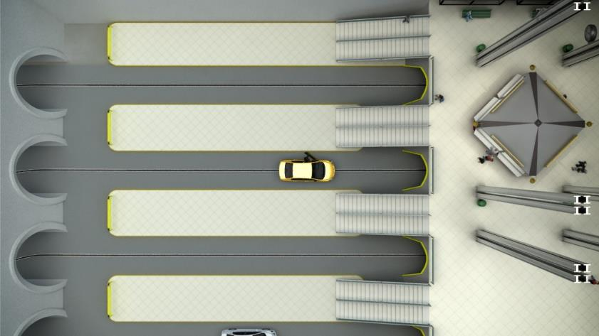
An overhead view of an underground Parking Control Center from our animation video. With multiple bays, multiple vehicles per bay, and automatic parking, the Center’s capacity can be enormous
The Parking Control Center is flexible in its response to changing situations. For example, at any one time, the bays may be given different assignments such as Embark or Disembark or Handicap Use or Emergency Use and so on. The system lends itself to a degree of flexibility that is unheard of in conventional public transport systems. To minimize human confusion, the bays at one end can even be segregated to, say, short term parking. The computer would have no problem organizing all of this.
Special cases for high traffic can easily be handled because TEV does it with a disciplined grace. The cars arrive and disappear as if choreographed. This is unlike the usual chaos in an airport arrival area for example. In a bright, cheerful Control Center there is no traffic noise, no diesel fumes, no ugly parking lot, and no dithering drivers who are lost and holding up traffic. This is what a proper introduction to a livable city should be like. You could arrange a wake-up beep from your cell phone as your car arrives at your destination. Everything is organized.
TEV can also make some new and radical options very practical, like connecting several regional airports to reduce noise or to relieve air or road congestion. For example, London could have Heathrow, Gatwick, and Luton coupled together in a system that could move a passenger from one to the other in a matter of 15 minutes. That would create an enormous “virtual” airport and provide much needed flexibility for travelers. So welcome to the new, improved city.

TEV is the evolution of the personal car, not public transport.
Dear Reader,
I hope you enjoyed this proposal. If you liked the simplicity of the TEV concept, help us get the word out. It is the best way to help reduce the huge amount of carbon fumes generated by road vehicles. This in every country in the world. There isn’t much time before it will be too late!
May you have many years of happy automatic driving in your high speed, non-polluting electric cars on the TEV System!
Will Jones.
Engineer and designer of the TEV system

